**ABINGTON P.A.L. RULES**

|  |  |
| --- | --- |
| **1.** | **ALL members of PAL MUST be Abington Township residents, or attending Abington Public Schools. -- NO Guests Allowed.** |
| **2.** | **Everyone must be 10 through 18 yrs. old.**  **PAL Membership expires upon graduation or the PAL members 19th birthday.** |
| **3.** | **Every member must have a PAL ID card, cards will be kept on site. No member is permitted to leave PAL without scanning out. Once you have left PAL for the evening you will not be admitted back into PAL.** |
| **4.** | **NO ONE will be admitted after 8:30pm** |
| **5** | **Appropriate dress is required! NO short shorts, tank tops, halter tops, midriff tops, boxer shorts, or anything with obscene or foul language on it. Shirts MUST be worn at all times. ONLY sneakers on basketball court, no flip flops, sliders or Crocs.** |
| **6.** | **EVERYONE is responsible for cleaning up / throwing away her or his own trash. As a member of PAL, team work clean-up is encouraged.** |
| **7.** | **NO drugs, alcohol, smoking, foul of disrespectful language. NO fighting, harassment, bullying.** |
| **8.** | **Negative Police contact outside of PAL, including the filing of charges / citations, will be reviewed, and may lead to suspension from PAL.** |
| **9.** | **Respect MUST be shown to the PAL staff and volunteers. Respect each other.** |
| **10.** | **ALL Members riding in the PAL van’s MUST wear their seat belt, and follow PAL site rules.** |

**PAL Site is open Friday and Saturday nights 7:00pm - 10:00pm**

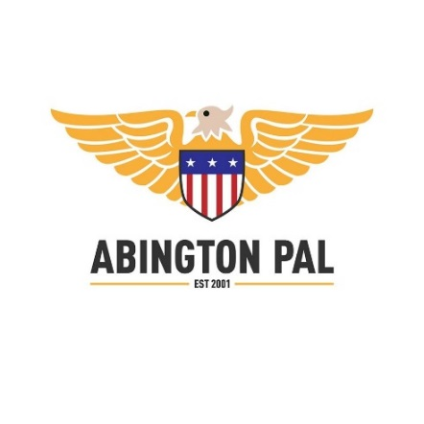**Violation of any of these rules will result in disciplinary action up to and including suspension from the PAL program. Further violations could result in dismissal.  
  
Abington PAL is not responsible for any personal items lost or stolen while at the PAL Center.**

PAL Member Acknowledgement: _____________________­­­­______

PAL Parent / Guardian ___________________________________

Date: _____________________